Google Cloud Build SQ-SAST
Integrate AccuKnox SonarQube-based SAST scanning into Google Cloud Build to catch source code vulnerabilities flagged by the SonarQube ruleset. The pipeline uses the AccuKnox ASPM Scanner CLI to run the Sonar Scanner, then forwards findings directly to your AccuKnox CSPM panel.

Prerequisites
• GCP project with Cloud Build enabled
• AccuKnox SaaS access with permission to generate tokens
• A SonarCloud or self-hosted SonarQube instance with a project already created
• A GitHub, GitLab, Bitbucket, or Cloud Source Repository connected to Cloud Build
• A Cloud Build trigger pointing at the repository you want to scan

Steps for integration

Step 1: Gather your credentials
You need credentials from two systems before configuring the pipeline.
AccuKnox
Log in to AccuKnox SaaS. Navigate to Settings> Tokens, then create a new token.
##Screenshot
SonarQube/SonarCloud
Open your SonarQube instance or sonarcloud.io. Find the project you want to scan, then grab the project key (Project Settings> Information). Then, create an auth token under My Account, then Security. For SonarCloud, also note your organisation key.
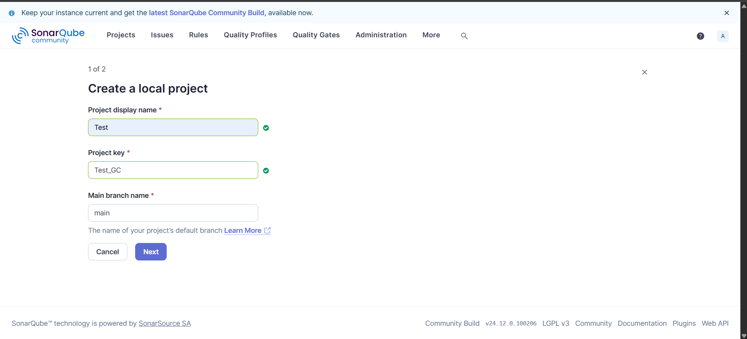
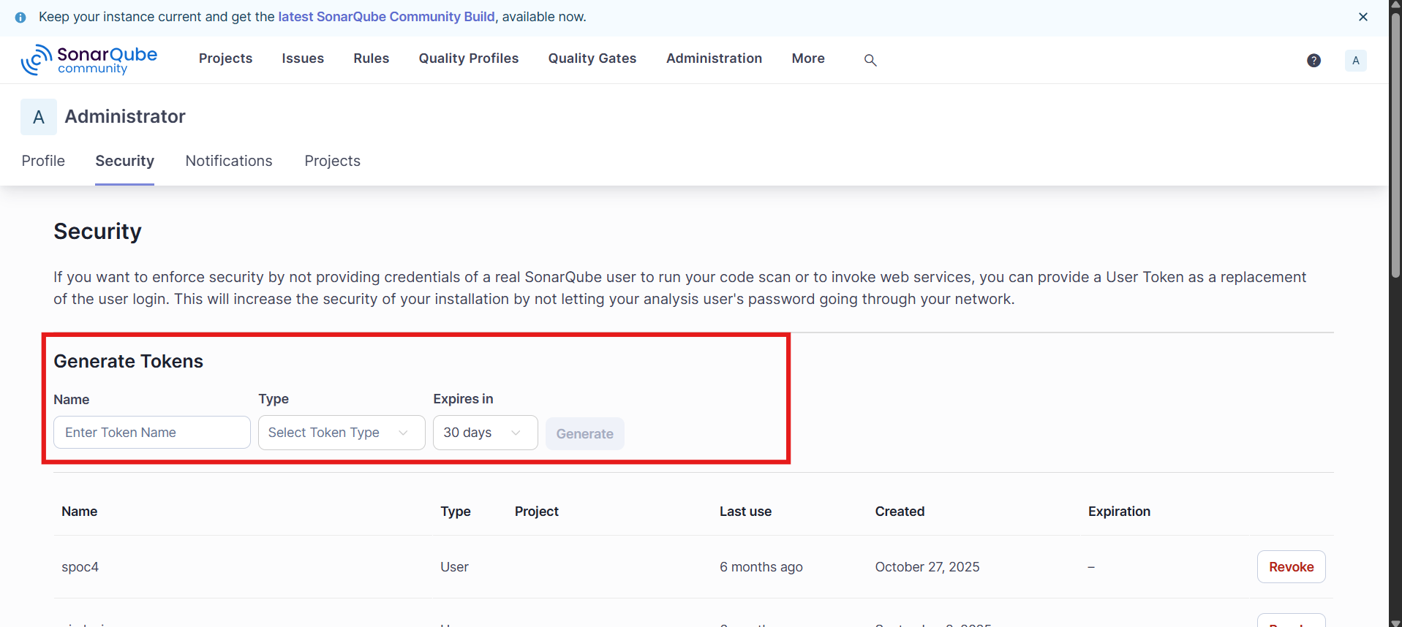
Save these values for use in Step 3:
Field | Where to find it
AccuKnox Endpoint | Your AccuKnox CSPM URL, for example, cspm.demo.accuknox.com
AccuKnox Token | The token string shown after creation
AccuKnox Label | Any descriptive string you choose
Sonar Project Key | Project Settings, then Information
Sonar Host URL | Your SonarQube URL or https://sonarcloud.io
Sonar Token | My Account, then Security, then Generate token
Sonar Organization | SonarCloud only, leave blank for self-hosted SonarQube

Step 2: Add the cloudbuild.yaml to your repository
Drop the following file at the root of your repository as cloudbuild.yaml.
# =============================================================================
# AccuKnox SonarQube SAST (sq-sast) - Google Cloud Build Pipeline
# Runs a SonarQube/SonarCloud scan and fetches results into AccuKnox CSPM.
# =============================================================================

steps:

# Step 1: Validate required inputs (fail fast)
- id: validate-inputs
name: ubuntu:24.04
entrypoint: bash
env:
- ACCUKNOX_ENDPOINT=${_ACCUKNOX_ENDPOINT}
- ACCUKNOX_TOKEN=${_ACCUKNOX_TOKEN}
- ACCUKNOX_LABEL=${_ACCUKNOX_LABEL}
- SONAR_PROJECT_KEY=${_SONAR_PROJECT_KEY}
- SONAR_HOST_URL=${_SONAR_HOST_URL}
- SONAR_TOKEN=${_SONAR_TOKEN}
args:
- -c
- |
set -e
if [ -z "$$ACCUKNOX_ENDPOINT" ] || [ -z "$$ACCUKNOX_TOKEN" ] || [ -z "$$ACCUKNOX_LABEL" ]; then
echo "ERROR: _ACCUKNOX_ENDPOINT, _ACCUKNOX_TOKEN, and _ACCUKNOX_LABEL must be set!"
exit 1
fi
if [ -z "$$SONAR_PROJECT_KEY" ] || [ -z "$$SONAR_HOST_URL" ] || [ -z "$$SONAR_TOKEN" ]; then
echo "ERROR: _SONAR_PROJECT_KEY, _SONAR_HOST_URL, and _SONAR_TOKEN must be set!"
exit 1
fi
echo "All required inputs present."

# Step 2: Download the AccuKnox ASPM Scanner CLI
- id: download-scanner
name: ubuntu:24.04
entrypoint: bash
args:
- -c
- |
set -e
export DEBIAN_FRONTEND=noninteractive
apt-get update -qq
apt-get install -y -qq --no-install-recommends curl ca-certificates

curl -sSL https://github.com/accuknox/aspm-scanner-cli/releases/download/v0.14.2/accuknox-aspm-scanner \
-o /workspace/accuknox-aspm-scanner
chmod +x /workspace/accuknox-aspm-scanner

# Step 3: Install Sonar Scanner, run the scan, upload results to AccuKnox CSPM
- id: run-sq-sast-scan
name: ubuntu:24.04
entrypoint: bash
env:
- SOFT_FAIL=${_SOFT_FAIL}
- SKIP_SONAR_SCAN=${_SKIP_SONAR_SCAN}
- ACCUKNOX_ENDPOINT=${_ACCUKNOX_ENDPOINT}
- ACCUKNOX_TOKEN=${_ACCUKNOX_TOKEN}
- ACCUKNOX_LABEL=${_ACCUKNOX_LABEL}
- SONAR_PROJECT_KEY=${_SONAR_PROJECT_KEY}
- SONAR_HOST_URL=${_SONAR_HOST_URL}
- SONAR_TOKEN=${_SONAR_TOKEN}
- SONAR_ORGANIZATION=${_SONAR_ORGANIZATION}
- REPO_URL=${_REPO_URL}
- BRANCH_NAME=${BRANCH_NAME}
- COMMIT_SHA=${COMMIT_SHA}
- BUILD_ID=${BUILD_ID}
- PROJECT_ID=${PROJECT_ID}
args:
- -c
- |
set -e

export DEBIAN_FRONTEND=noninteractive
apt-get update -qq
apt-get install -y -qq --no-install-recommends ca-certificates default-jre-headless

/workspace/accuknox-aspm-scanner tool install --type sq-sast

SOFT_FAIL=$(echo "$$SOFT_FAIL" | tr -d ' \t\r\n')
SOFT_FAIL_ARG=""
if [ "$$SOFT_FAIL" = "true" ]; then
SOFT_FAIL_ARG="--softfail"
fi

SKIP_SCAN_ARG=""
if [ "$$SKIP_SONAR_SCAN" = "true" ]; then
SKIP_SCAN_ARG="--skip-sonar-scan"
fi

SONAR_ORG_FLAG=""
if [ -n "$$SONAR_ORGANIZATION" ]; then
SONAR_ORG_FLAG="-Dsonar.organization=$$SONAR_ORGANIZATION"
fi

SONAR_CMD="-Dsonar.projectKey=$$SONAR_PROJECT_KEY -Dsonar.host.url=$$SONAR_HOST_URL -Dsonar.token=$$SONAR_TOKEN $$SONAR_ORG_FLAG"

PIPELINE_URL="https://console.cloud.google.com/cloud-build/builds/$$BUILD_ID?project=$$PROJECT_ID"
if [ -z "$$COMMIT_SHA" ]; then
COMMIT_SHA="manual-$$BUILD_ID"
fi

BRANCH_ARG=""
if [ -n "$$BRANCH_NAME" ]; then
BRANCH_ARG="--branch $$BRANCH_NAME"
fi

/workspace/accuknox-aspm-scanner scan --keep-results $$SOFT_FAIL_ARG sq-sast \
--command "$$SONAR_CMD" \
$$SKIP_SCAN_ARG \
--repo-url "$$REPO_URL" \
$$BRANCH_ARG \
--commit-sha "$$COMMIT_SHA" \
--pipeline-url "$$PIPELINE_URL"

substitutions:
_ACCUKNOX_ENDPOINT: ""
_ACCUKNOX_TOKEN: ""
_ACCUKNOX_LABEL: ""
_SONAR_PROJECT_KEY: ""
_SONAR_HOST_URL: ""
_SONAR_TOKEN: ""
_SONAR_ORGANIZATION: ""
_REPO_URL: ""
_SOFT_FAIL: "true"
_SKIP_SONAR_SCAN: "false"

options:
logging: CLOUD_LOGGING_ONLY
machineType: E2_HIGHCPU_8

timeout: 3600s

Commit and push the file to your repository.

Step 3: Configure the Cloud Build trigger
Open Cloud Build in the GCP console. Create or edit a trigger pointing at your repository.
Under Configuration, select Cloud Build configuration file and point it at cloudbuild.yaml.
Under Advanced, then Substitution variables, add:
Variable name | Value
_ACCUKNOX_ENDPOINT | Your CSPM endpoint, for example, cspm.demo.accuknox.com
_ACCUKNOX_TOKEN | The AccuKnox token from Step 1
_ACCUKNOX_LABEL | A label of your choice, for example, sq-sast-myapp
_SONAR_PROJECT_KEY | The SonarQube project key, for example, my-org_my-repo
_SONAR_HOST_URL | Your SonarQube URL, for example, https://sonarcloud.io
_SONAR_TOKEN | The SonarQube auth token from Step 1
_SONAR_ORGANIZATION | optional. SonarCloud organization key. Leave blank for self-hosted SonarQube.
_REPO_URL | Your repo URL, for example, https://github.com/your-org/your-repo.git
_SOFT_FAIL | optional. true (default) or false to fail the build on findings
_SKIP_SONAR_SCAN | optional. false (default) or true to skip the Sonar scan and only fetch existing results
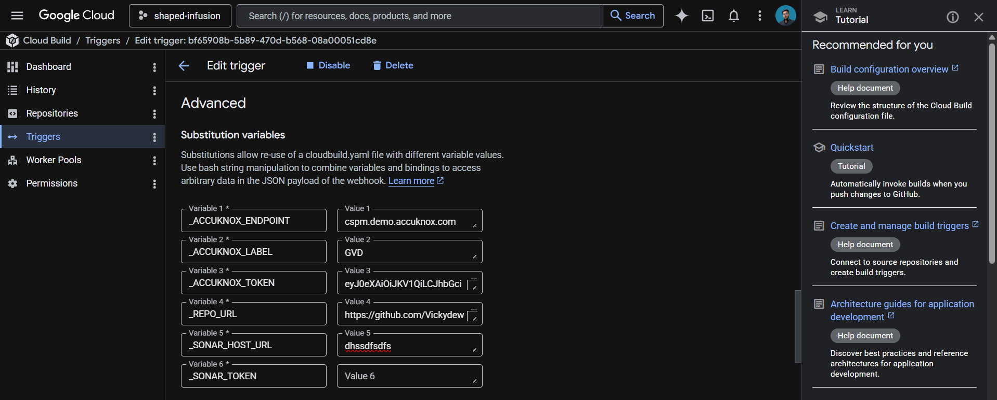

These values live in the trigger config rather than the YAML, which keeps your tokens out of git history.
Save the trigger. The next push to the watched branch runs the pipeline.

How the pipeline works
Step | Purpose
1. validate-inputs | Fails the build in under a second if any required AccuKnox or SonarQube credential is missing. Saves a wasted scanner download.
2. download-scanner | Fetches the AccuKnox ASPM Scanner v0.14.2 binary into /workspace, which persists across Cloud Build steps.
3. run-sq-sast-scan | Installs the SonarQube Scanner locally, runs the scan against your codebase, fetches the results from SonarQube, and uploads findings to AccuKnox CSPM.

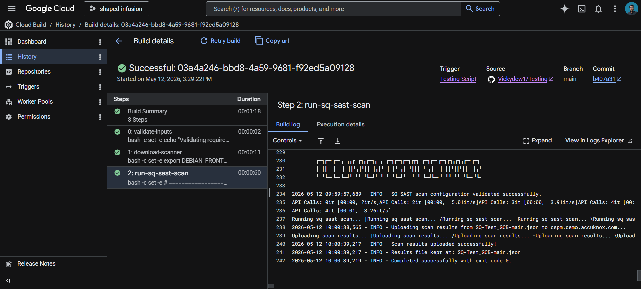

Skip the scan, fetch only
If your SonarQube scan already runs in another pipeline (for example, a separate GitHub Action or a different Cloud Build trigger), you don't need this pipeline to run the scan again. Set _SKIP_SONAR_SCAN to true, and the AccuKnox scanner will pull the latest results from SonarQube and forward them to CSPM without rerunning anything.
For most setups, leave _SKIP_SONAR_SCAN as false so scan and upload happen in one go.

Viewing results
Open the AccuKnox CSPM panel. Filter findings by the label you set in _ACCUKNOX_LABEL. Each finding includes the file, line number, SonarQube rule ID, severity, and a link back to both the Cloud Build run and the SonarQube issue.

Before the AccuKnox scan
Without SonarQube SAST integration in your pipeline, code quality and security issues that SonarQube flags stay siloed in the SonarQube UI. Security teams using AccuKnox as their single pane of glass have to context-switch to SonarQube to triage these findings, and they don't appear alongside cloud, container, or IaC risks.

After AccuKnox scan integration
Once the pipeline above is wired up, every push triggers the SonarQube scan and the results land in AccuKnox CSPM alongside findings from every other scanner. SQL injection, hardcoded credentials, insecure deserialization, and other Sonar-flagged issues appear with severity, file location, and remediation guidance in one place. Critical issues can fail the build by toggling _SOFT_FAIL to false.
